# Week 2, Technical and Professional Writing 1025-70

Jean Lunde

# How to Create an Assignment Due Reference in Excel Using Conditional Formatting

**Objective**

**When you choose a particular date from a date dropdown list, the assignments due on that date will display with a green background.** Figure 1 shows an example. The instructions below show how to accomplish this task.

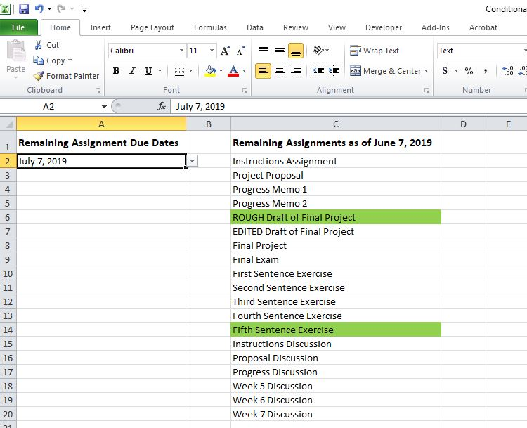**Fig. 1.** Date selection example from the finished reference sheet.

**Required Skillset**

An intermediate skill level in Excel is recommended; however, by carefully following the step-by-step instructions, you may successfully accomplish this task even if you have only beginner level skills.

**Roadmap**

You’ll first create a drop down text box using Excel’s Data Validation tool. The box will contain a list of due dates. Then, using Excel’s Conditional Formatting tool, you’ll write rules to link each of the dates to their corresponding assignments and cause each assignment’s background to turn green when you select its due date.

**Open Excel spreadsheet file “Conditional Formatting Exercise_Start.xlsx.”**

The spreadsheet is prefilled with content to save you time. It contains a list of the remaining assignments for ENGL 1025 along with a list of the remaining due dates. (Quizzes are not included.) You will work in this spreadsheet.

The correspondence between assignments and due dates is yet absent from the spreadsheet. You will create that correspondence as you follow these instructions.

**Create a drop down box that contains the list of remaining assignment due dates.**

1. Click on cell A2. (If you’re not familiar with Excel, each cell is identified by its column and row, in this case, column A, row 2.)
2. Then click on the **Data** tab. Select **Data Validation** > **Settings** (Figure 2).

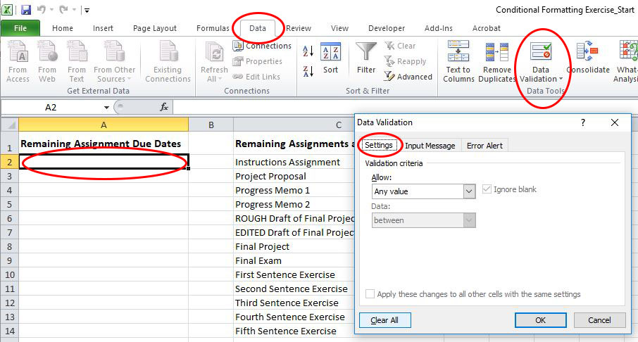**Fig. 2.** Data validation sequence.

1. From the **Allow** dropdown list, select **List**. Make sure that the **In-cell dropdown** checkbox is checked. Then click inside the **Source** text box. (See Figure 3.)

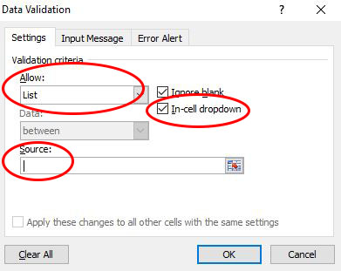

**Fig. 3. “**Data Validation” window selections.

1. Scroll down the spreadsheet to row 50. While holding down your left mouse button, cursor over cells A50–A62. Doing so should automatically populate the **Source** text box. You should see **$A$50:$A$62** in the text box. Click **OK**. (See Figure 4.)

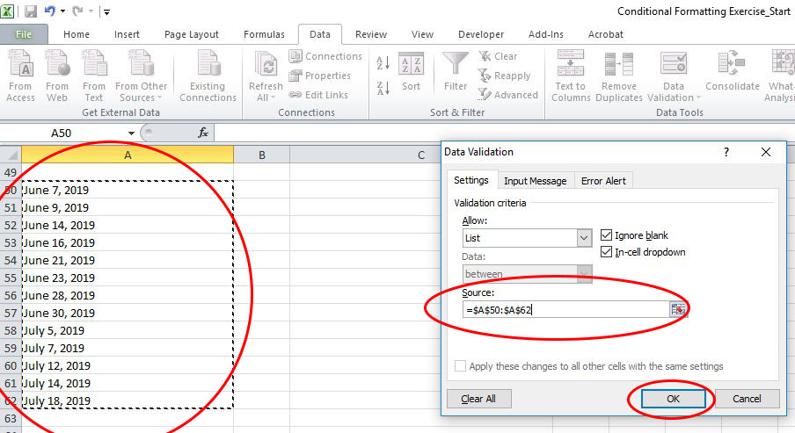

**Fig. 4.** Insertion of the cell references into the “Source” text box.

You should now see an arrow to the right of cell A2 (Figure 5). This arrow indicates the presence of a dropdown list. Click the arrow to make the dropdown date list visible.

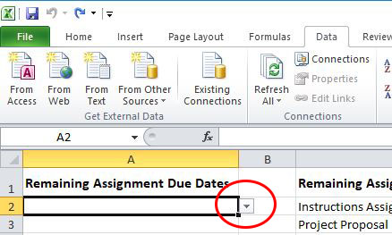

**Fig. 5.** Arrow indicating a dropdown list.

**BTW**: The placement of the list of due dates on the pre-filled spreadsheet was not important. The list could have been placed anywhere on the spreadsheet or even on a separate spreadsheet. In this example, it was placed towards the bottom to get it out of the way. It’s a reference list that may later be hidden if desired. To learn how to hide rows in Excel, see <https://support.office.com/en-us/article/hide-or-show-rows-or-columns-659c2cad-802e-44ee-a614-dde8443579f8>.

**Set up formatting rules for the items in the assignments list. These rules will enable the conditional color formatting.**

1. Select date June 7, 2019 from the dropdown list in cell A2.
2. From the **Home** tab, go to **Conditional Formatting** > **Manage Rules** (Figure 6.)

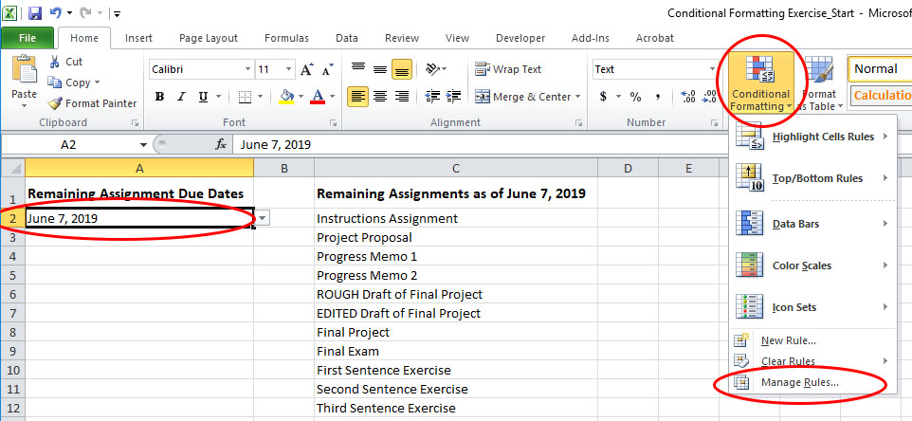**Fig. 6. “**Manage Rules” selection.

1. In the window that appears, click on **New Rule** (Figure 7).

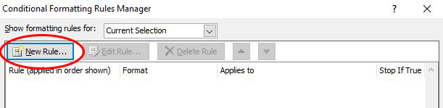**Fig. 7. “**New Rule” selection.

1. In the window that then appears, select **Use a formula to determine** **which cells to format**. Click **OK**. (See Figure 8.)

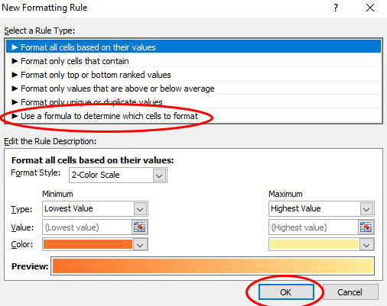

**Fig 8. “**Rule Type” selection.

1. In the window that appears next, click in the **Format values where this formula is true** text box (Figure 9).

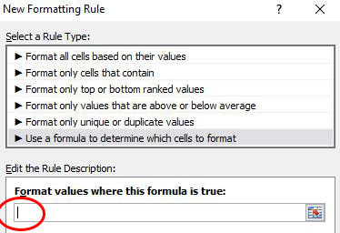

**Fig. 9. “**Format value where this formula is true” text box selection.

1. Then click on spreadsheet cell A2. Doing so should automatically populate the **Format values where this formula is true** text box. You should see **=$A$2** in the text box (Figure 10).

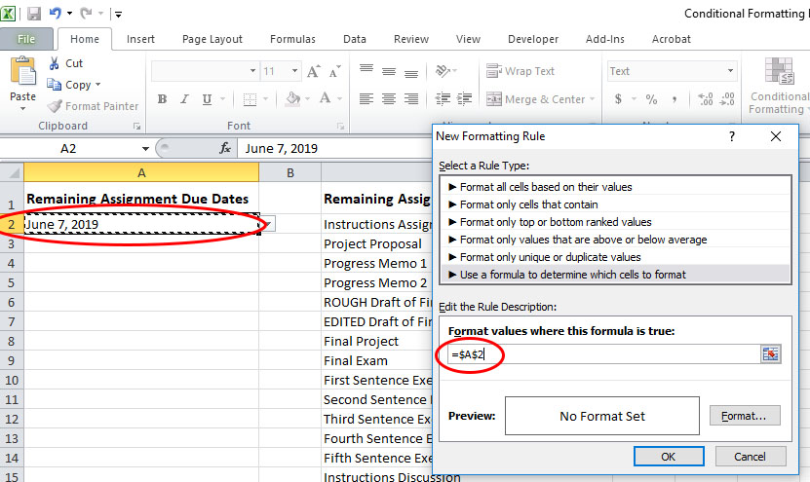**Fig. 104.** Insertion of the A2 cell reference in the “Format value where this formula is true” text box.

1. Type **=”June 7, 2019”** immediately after the text that appeared. The rule should then read **=$A$2=”June 7, 2019”.** Then click the **Format** button**.** (See Figure 11.)

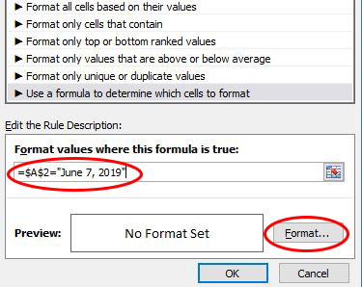

**Fig. 11.** Additional rule text and Format button selection.

1. In the window that appears, select the **Fill** tab, then select the green fill shown in Figure 12. Click **OK**.

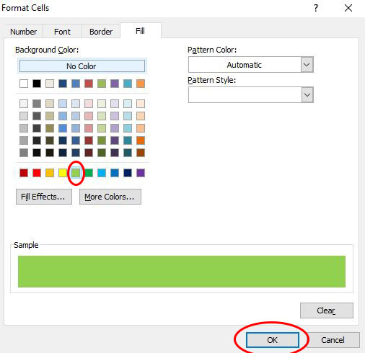

**Fig. 12.** Green fill format selection.

1. Click **OK** again in the window that appears (Figure 13).

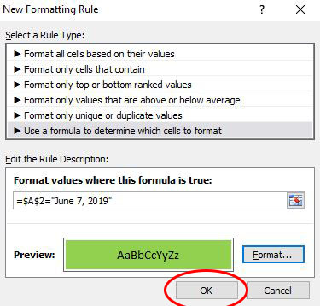

**Fig. 13. “**OK” selection in the “New Formatting Rule” box.

1. In the window that next appears, delete the default text you see in the **Applies to** text box (Fig. 14).

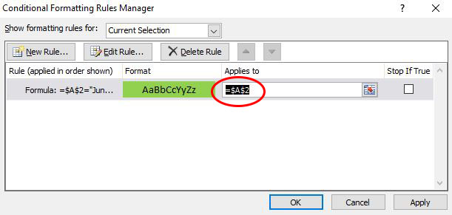

**Fig. 14.** Deletion of the default text in the “Applies to” text box.

1. Make sure that your cursor is still in the **Applies to** text box. Click on spreadsheet cell C15. You should now see text **$C$15** in the text box. Click **Apply**, and then click **OK**. (See Figure 15.)

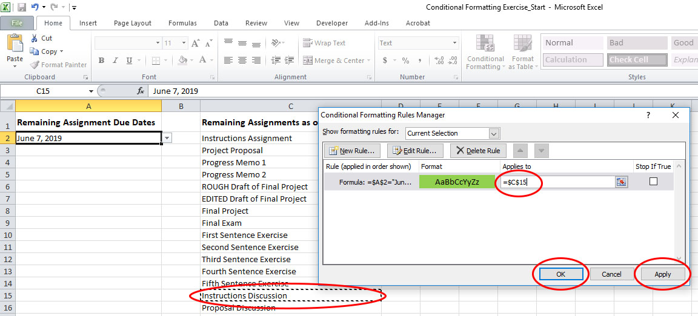**Fig. 15.** Insertion of the C15 cell reference in the “Applies to” text box.

The *Instructions Discussion* assignment (cell C15) should now display a green background when you choose date June 7, 2019 from the A2 cell dropdown list (Figure 16**). Congratulations! You’ve now completed the conditional formatting rule for date June 7, 2019!**

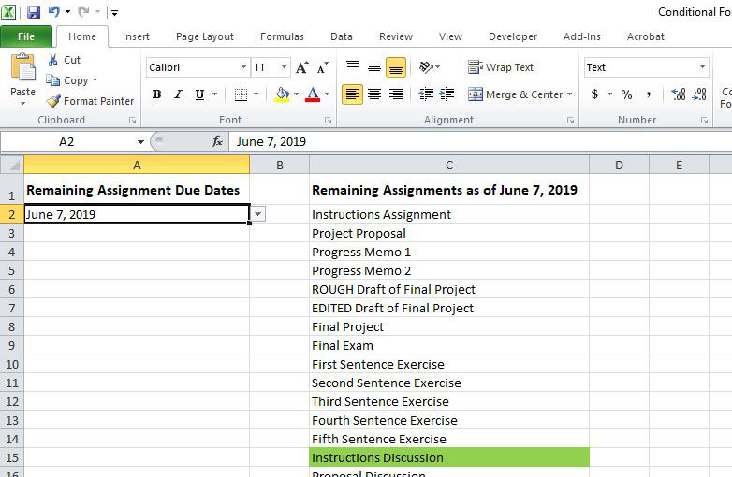

**Fig. 16.** Successful rule completion for date June 7, 2019.

**BTW**: You may produce any desired combination of formatting when you use conditional formatting. This includes such things as fill color, font color and styling, border, etc.

If you are not familiar with the dollar sign symbol preceding a cell’s column and row identification, you can read more about it here: <https://www.microsoft.com/en-us/microsoft-365/blog/2011/08/17/making-sense-of-dollar-signs-in-excel/>.

**Create the conditional formatting rules for the remaining due dates and assignments.**

1. Select the next date listed in cell A2’s dropdown box.
2. From the **Home** tab, once again go to **Conditional Formatting** > **Manage Rules**.
3. Select **This Worksheet** from the **Show Formatting Rules for** dropdown box in order to view all the rules.
4. Repeat steps 3–11 from the previous section to create a new rule for each of the remaining dates in cell A2’s drop down list. For each new rule, make the necessary changes to the date in the **Rule** formula and to the cell references in the **Applies to** text box. For your convenience, a reference table is included on page 13 listing the assignments and due dates.

**Keep in Mind – Important!**

* The syntax for **Applies to** is: **=[cell number]**. If there is more than one cell number—as is the case with the two June 9 assignments—you must insert a comma between the cell references. In this case, the text in the **Applies to** text box should read: **=$C$2,$C$10**.
* The syntax for each rule is: **=$A$2=”[due date]”**. For example, the next date’s rule should read  **=$A$2=”June 9, 2019”**. Text **$A$2** stays constant, since it represents the cell containing the dates. Make sure you enclose the selected date which follows in quotation marks.
* Keep the **format** (green fill) consistent for all the assignments.
* Don’t forget to select **This Worksheet** when you want view all of your formatting rules. If you don’t, you’ll see only the default **Current Selection** rule.

**CAUTION:**

**When creating the rules, do not forget the equals’ signs or the quotation marks surrounding the due date! Make sure to enter the date exactly as it’s entered in the dropdown list. If the green formatting does not appear as expected, check the rules for possible syntax errors involving these details. From the Manage Rules window, you may edit your rules if necessary.**

Note: If you cannot finish creating all of the new rules in the allotted time, don’t worry. Try creating just one or two rules to see if you can successfully produce the green formatting. You get the idea! ☺

File **Conditional Formatting Exercise_Finished.xlxs** is included if you want to compare your rules. Open the file, then from the Home tab go to **Conditional Formatting** > **Manage Rules**. Select **This Worksheet** to view the entire worksheet rules. Figure 17 displays a partial list of the rules. Scroll down in the window to view all of them.

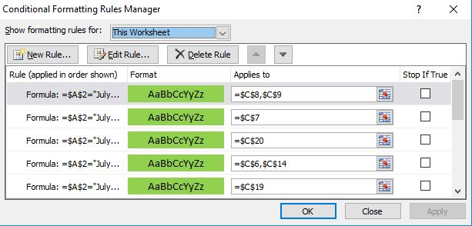**Fig. 17. A p**artial listing of the finished conditional formatting rules in file **Conditional Formatting Exercise_Finished.xlxs** .

|  |  |
| --- | --- |
| **Due Date** | **Assignment** |
| June 7, 2019 | Instructions Discussion |
| June 9, 2019 | Instructions Assignment |
| June 9, 2019 | First Sentence Exercise |
| June 14, 2019 | Proposal Discussion |
| June 16, 2019 | Project Proposal |
| June 16, 2019 | Second Sentence Exercise |
| June 21, 2019 | Progress Discussion |
| June 23, 2019 | Progress Memo 1 |
| June 23, 2019 | Third Sentence Exercise |
| June 28, 2019 | Week 5 Discussion |
| June 30, 2019 | Progress Memo 2 |
| June 30, 2019 | Fourth Sentence Exercise |
| July 5, 2019 | Week 6 Discussion |
| July 7, 2019 | ROUGH Draft of Final Project |
| July 7, 2019 | Fifth Sentence Exercise |
| July 12, 2019 | Week 7 Discussion |
| July 14, 2019 | EDITED Draft of Final Project |
| July 18, 2019 | Final Project |
| July 18, 2019 | Final Exam |

Reference Table of Remaining Due Dates and Assignments